Customer Survey
Dear Customer,
We greatly appreciate you taking the time to provide feedback on our products and/or our company.
Product Questionnaire
Product Name:
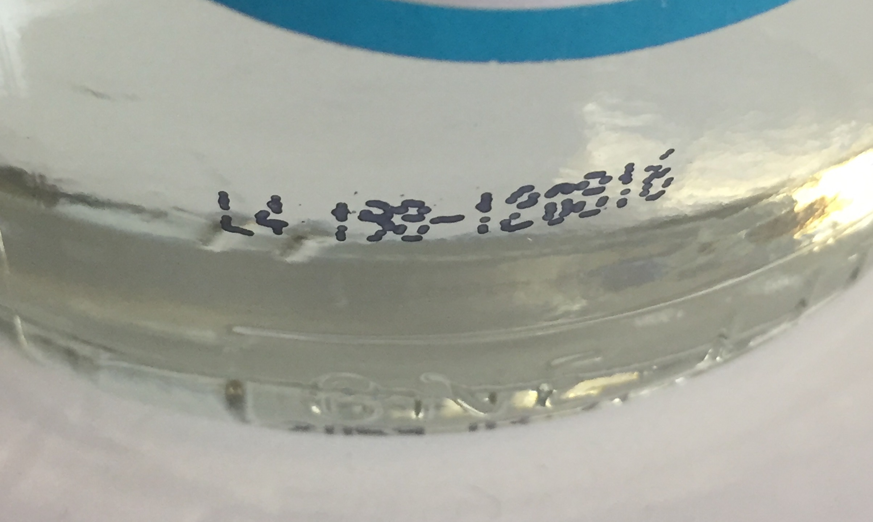
Product Code:
(This can be found in black ink printed directly
on the bottle outside of the normal labels)

Please rate your overall satisfaction with our product: 1 2 3 4 5
Poor Fair Average Good Excellent

Please provide any questions or concerns you may have with our product:
*You may also submit a picture of the product with this survey
Company Questionnaire
Are there any new products or services you would like to have?

Please provide any suggestions or concerns:

Additional Comments:

Thank you for completing the Customer Survey. If you had any questions, a Frank-Lin Representative will follow up with you at their earliest convenience.
Please provide your contact information:
Name: Phone #:
Email Address:
Once you have completed this survey you can email it to cmm@frank-lin.com or fax it to 408-649-5045

